UI errors

Workshop #04

Flutter Developer Bootcamp

# **Purpose**

This workshop demonstrates how to fix the UI errors.

# **Problem**

In the given workshop scenario, an overflow error occurs when users input data into a text field. You aim to resolve this overflow error.

**How to Solve**

1. Checkout the workshop from Git Repo:

git clone -b <user-branch> <repo-URL>

2. Open the root folder inside VS Code

3. To build the app click the run option in the main method { }

4. Fix the app's interface issue by using some widgets.

# **You Will Achieve**

When you complete this workshop, you will learn how to handle UI errors in the application, and you will also learn how to create an application without any overflow errors.

# **Screenshots**

## **Before implementation (Without Error Handling)**

## **After implementation (With Error Handling)**

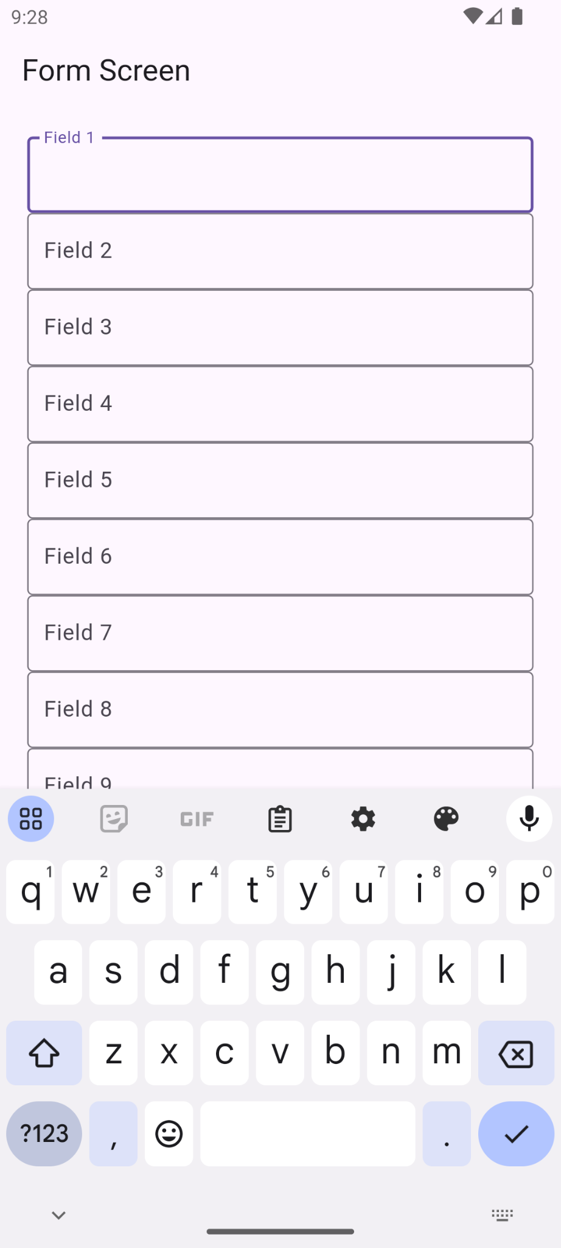

# **How to submit your workshop**

Push your project back to the same git branch using command:

<command name>

# **Happy Coding!**